
McKinney North sophomore stars in new horror film
- Mar 27, 2018
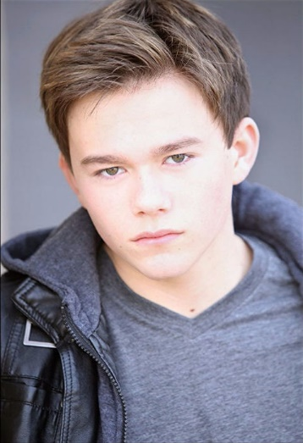
Jake Ryan Scott
Nearly two decades before McKinney North High School sophomore Jake Ryan Scott was born, the creepy kids of “Children of the Corn” was making parents sleep with one eye open. Since the original film was released in 1984, sequels have kept the horror alive. Now, Scott is starring in the newest installment “Children of the Corn: Runaway.” The 16-year-old, son of Drs. Donna Kobrin and Terry Scott, stars as Aaron in the film. Scott, who is a fan of the horror genre has also appeared in the TV series "American Horror Story," "Dallas" and "Movie Guy," and he can be seen in commercials and local plays. Scott is in varsity theatre and varsity debate at McKinney North High School, and he performs prose, humorous interpretation and duet for the varsity debate team. He is also on the board of directors for the Young Actors Guild in McKinney.
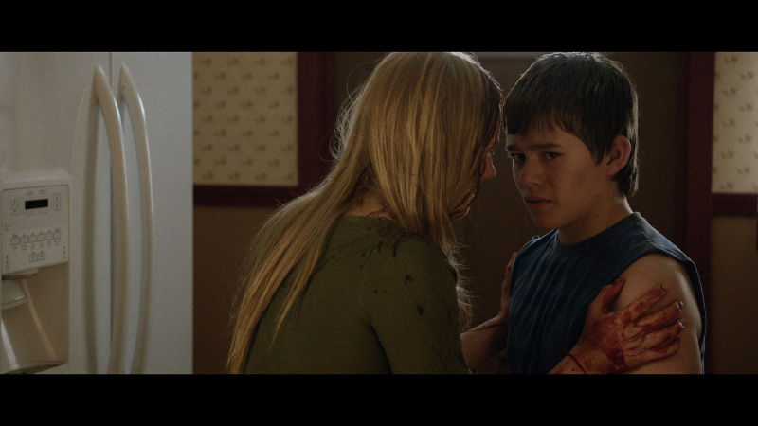

How long have you been acting, and how did you get into it?
I have been acting for 10 years now. I got into acting by going to see local stage plays at the McKinney Performing Arts Center. One of the first plays I remember seeing was a yearly performance of Charles Dickens “A Christmas Carol”. I said to my parents that I wanted to be Tiny Tim next year. I auditioned and landed the role.
What's the best part of acting?
The best part of acting is being able to portray many different characters and to explore all their different emotions, to have the opportunity to live another persons life, to feel they way they feel, to see what they see, and act they way they act especially when it is so different than who I really am. I also love the many connections you get to make with other actors. Because of the long hours on set you build friendships quickly even though you may only be working with them for a few weeks or a month.
The most challenging?
The most challenging part of acting has to be the initial audition. For most auditions you go in pretty blind to the character, but it is fun to create a background for them based on your own perspective.
How did you prepare for the new role?
I prepared every scene by digging deep into who Aaron is and why. Aaron is not a typical 13-year-old; he is most often sullen, quiet and very rarely trusting. His emotions are definitely more guarded than the overdramatic typical 13-year-old. He has never attended school, made friends, and never lived in one area for very long. So for me I tried to view that world through his eyes. How would that teenager act and react to each event in his life? I prepared by pinpointing his motivation for each and every scene.
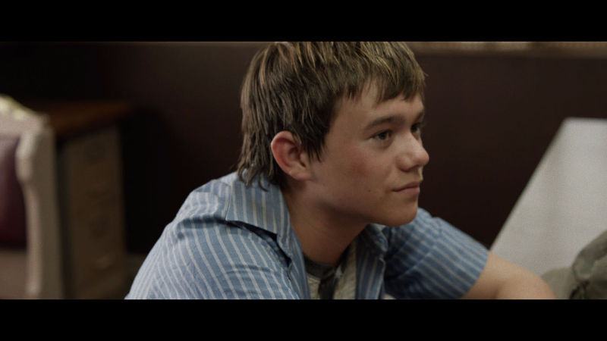

Did you watch the older Children of the Corn movies?
During the filming process we were actually instructed to not watch the older movies because (director) John Gulager wanted to do a complete 180 from the first film and explore a new environment outside of the original cornfield and also express the mental strain the past had on Ruth.
Do you have any special plans for the release?
For the release I will be having a private showing with friends and family members.
What types of movies are you into?
I am into a lot of movies ranging from my favorite comedy ‘Borat' to the portrayal of Mozart's life in ‘Amadeus'. But I also really like darker movies, like all of Quentin Tarantino’s films.
What actors/actresses inspire you?
One actor that really inspires me is Leonardo DiCaprio, because you can always tell he is a completely new being with each movie. For instance, in the film ‘Django Unchained' he hits a glass on the table, which was unscripted, and he starts bleeding, but the psychotic features of his character would not stop his thought so he did not stop the scene.
What are your long-term plans? Will you continue acting?
My long-term plan is to be classically trained in the theatrical arts, preferably in Europe and have a career as a steady actor.
Do you have any hobbies outside of your work?
Outside of my film work I mostly work in theatre with the Young Actors Guild in McKinney.
What's your Netflix binge right now?
My Netflix binge right now is probably 'The Good Place,' but I watched the first episode of 'A-typical’ and really enjoyed the cast so I think I will probably watch that as a binge.
What's your favorite McKinney hangout?
There are limited options, but if I had to choose a broad place it would be downtown because there are a lot of great restaurants and cool antique shops.

